LaToya Evans
Head of Corporate Public Relations, Ally Bank
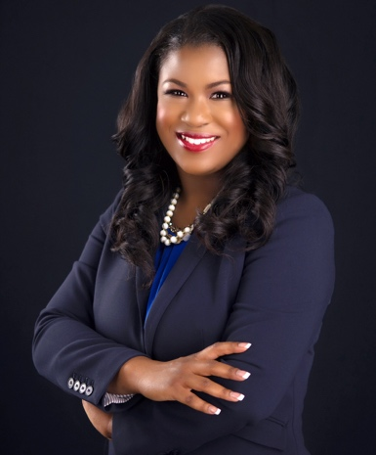
LaToya Evans is a strategic communications executive who has served as senior crisis communications counsel and spokesperson for some of the world’s most notable brands including Walmart, Bank of America, IBM, Philips, and Compass Group. Currently, she serves as head of corporate brand public relations for Ally Bank and also owns a boutique PR firm where she leads media and marketing initiatives for some of Charlotte’s most high-profile businesses, politicians and professional athletes. Notably, in 2017, LaToya also served as chief communications officer to former Charlotte, NC Mayor Pro Tem Vi Lyles, serving as a spokesperson and chief writer for her mayoral campaign which resulted in Lyles being elected the city’s first African American woman mayor.

Most recently, she’s served as the Head of Communications, North and South America, for Cisco Systems. Prior to her role at Cisco, LaToya served as Vice President and Head of Communications for the U.S. corporate dining division of Compass Group, the world’s largest foodservice company, reporting to the CEO and overseeing all aspects of corporate communications. LaToya also previously served as Vice President, Corporate Communications at Bank of America Corporate where she oversaw media relations for the east coast and northeast including crisis communications for the region. Prior to Bank of America, she was Senior Manager of U.S. Media Relations at Walmart Corporate, the world’s largest company, where she headed strategic media relations for six retail divisions and served as a national media spokesperson. She previously lived in New York and oversaw media and various entertainment partnerships across the U.S. for Philips Electronics and managed communications for IBM’s global technology services division, writing for the inventor of the IBM personal computer and LASIK eye surgery. Prior to a corporate career, Ms. Evans ran a freelance writing business, working often for Glamour magazine.
Ms. Evans is also active in the community. Recently, she was appointed by the Charlotte City Council to serve on the Community Relations Committee - which is designed to promote equality in North Carolina’s largest city - where she specifically works on the city’s crisis response efforts. Additionally, she sits on a c-suite advisory board for M&F Bank, one of the country’s largest black-owned financial institutions and is a member of the University of North Carolina at Chapel Hill’s School of Media and Journalism alumni board. Previously, LaToya served on the state committee for Miss North Carolina as the Director of the Children’s Miracle Network Hospitals overseeing fundraising and charity efforts for the state program. With fundraising and charity being a passion for LaToya, she also served in a leadership role within the Junior League of Charlotte as the chair of public relations and marketing for the fund development council. She is a member of Alpha Kappa Alpha Sorority, Inc. and has also previously been honored as a Rising PR Star by PR News (2016); one of Charlotte’s 50 Most Influential Women (2017); and Charlotte Business Journal’s 40 Under 40 (2018). Evans has also been an adjunct communications professor at Fayetteville Technical Community College for the last five years.

She holds a master of arts in organizational leadership with a concentration in crisis communications from Marist College in Poughkeepsie, NY and a bachelor of arts in journalism and mass communication from the University of North Carolina at Chapel Hill. She is a graduate of E.E. Smith High School where the LaToya Evans Academic Excellence Scholarship has been given in her honor annually since 2004.

